1st KARL SEALY MEMORIAL OPEN

January 18-21
Press Release: WARNER WINS KARL SEALY MEMORIAL

FIDE master Delilse Warner scored an impressive 6-½ points from 7 to take the inaugural Karl Sealy Memorial Chess Tournament and send a clear warning shot as to his intentions for this year’s National Chess Championships.

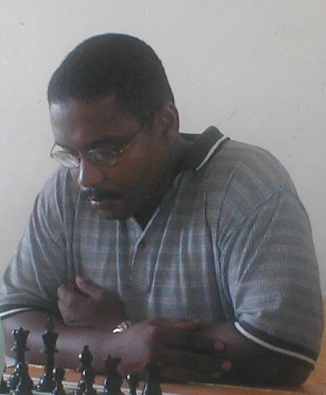
FIDE Master Delisle Warner

He capped a fine tourney win with victories over the number one and two seeds Terry Farley and FIDE master Philip Corbin and a draw against Trinidad and Tobago National Champion FIDE master Ryan Harper.

Veteran, Othneil Harewood , also found the going good with a second place finish on 5 ½ points. His only lost was to Warner and but produced a big upset win in round two when he defeated Trinidad Champ Ryan Harper.

This win no doubt lifted Harewood’s confidence and even when he seemed lost in a later game against Lyndell Halliday, he fought tooth and nail to salvage a draw.

Top seed Terry Farley came third. He also defeated Harper, in the last round, but losses to Warner and first round default cost him dearly.

Trinidad Champ Harper came in fourth, while FIDE Master Dr. Philip Corbin had to settle for fifth on the tie break.

The Under 1600 Rating Section was also keenly contested going down to the last round. The eventual joint winners on 5 points from a possible 6 were Michael Barker and Dwayne Gilkes.

Barker, a teacher from the Parkinson School, seemed heading towards a memorable victory until he lost in round 5 to top seed Gilkes.

This opened the door for Gilkes who had suffer a massive first round upset to Lodge School junior Dominic del Castilho .

In joint third position was Alex Carrington of the Barbados Community College, Corey Morgan and in his debut tournament, Jeffrey Hayes.

Morgan lost his bid for joint first when he went down to Gilkes in the final round.

Top junior Brian Branch of the Lodge School dominated the Under 14 Section scoring 5 ½ from 6 to win by a full point.

He drew his final game against Justin Blackman of St. Cyprian’s Primary, which allowed Blackman to finish second.

Branch fresh from an impressive performance in the Trinidad and Tobago Junior Open continues to improve and with his calm temperament seems a player set for good things.

National Under 12 Champion, Sumant Nanduri also of St. Cyprians edged out Emmeron Hurley of the Garrison for third, with both players gaining four points.

Other worthwhile performances came from Thomas Parris of The Lodge School, Kamel Carter of Louis Lynch and Marcus Greene of Harrison College.

