FOR IMMEDIATE RELEASE!!!

Paris Hilton, Usher and the HB Global Chess Challenge

What will screen vixen Paris Hilton, R & B superstar Usher and the winner of the HB Global Chess Challenge have in common? They will all be sporting the same glamorous accessory on their wrists. Polanti Watches, makers of luxury time pieces, has agreed to donate one of their dazzling instruments from their 3 Time Zone collection to the top performer in the Open section of the Minneapolis tournament. The HB Global Chess Challenge, the world’s richest open tournament with a record-breaking prize fund of $500,000, is already rewarding the winner of its premier section with a first place prize of $50,000.
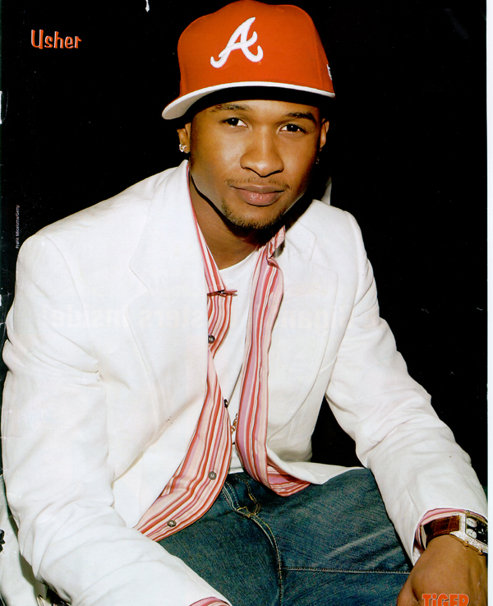
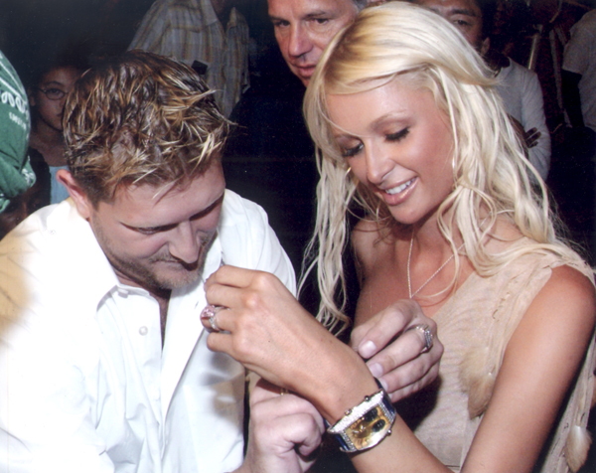
The watch, which has a retail value of $7,000, is studded with 200 diamonds totaling 4.4 carats.

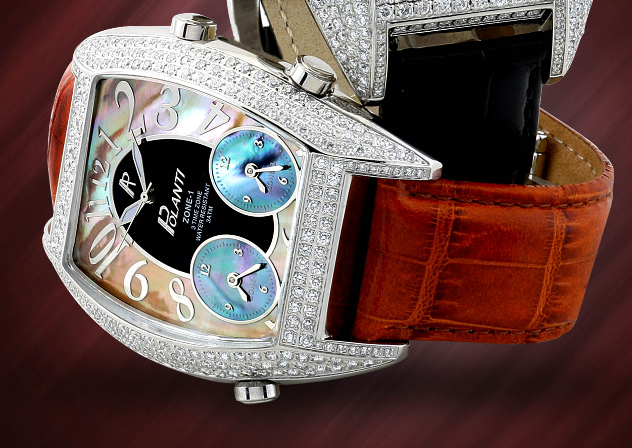

Polanti Watches have lately been seen on the wrists of such well-known celebrities as actor Sylvester Stalone, rap star Eve, American Idol Ruben Studdard, basketball player Derek Fischer, and cover girl Natasha Henstridge. The collections include the Ice Zone, G Zone, Natina, Dolce and Tulips, and can be found of at the company’s web sites at www.polanti.com and www.polantiusa.com.
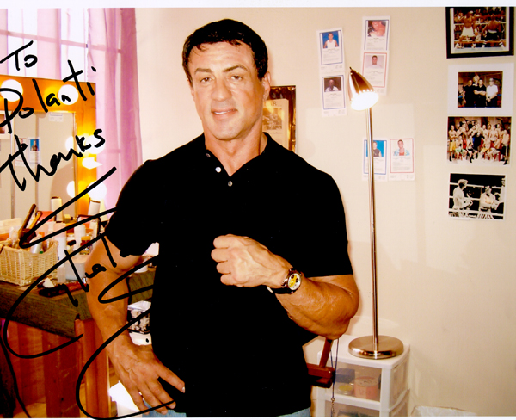

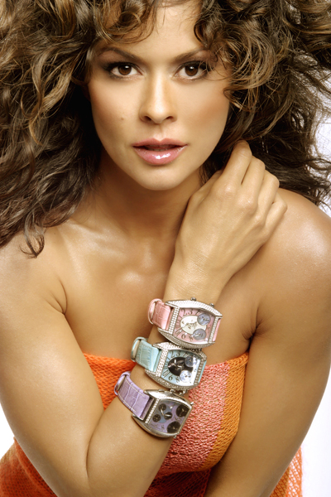

The HB Global Chess Challenge, running from May 18-22 at the Minneapolis Convention Center in Minneapolis Minnesota, will be giving away more than 320 prizes in 7 sections. The tournament is designed to benefit the HB Foundation, whose mission is to spread the message about the benefits of chess for young people. Register to play now at www.hbfoundation.org

