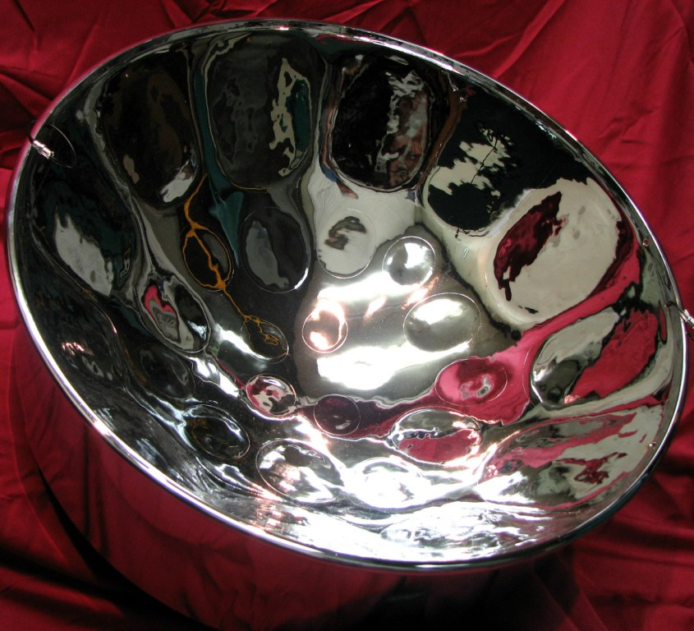

**TRINIDAD AND TOBAGO**

**INTERNATIONAL**

**MASTERS AND OPEN**

**CHESS TOURNAMENTS**

***July 28th – August 5th, 2016***

**Invitation**

**In 2016, the Trinidad & Tobago Chess Association (TTCA) celebrates its 80th Anniversary. In commemoration of this milestone, the (TTCA) is pleased to invite all National Federations to the Trinidad and Tobago International and Masters Open (TTIMO) Chess Tournaments 2016 to be held at The Normandie Hotel, St. Anns, Trinidad, from 28th July through 5th August, 2016.**

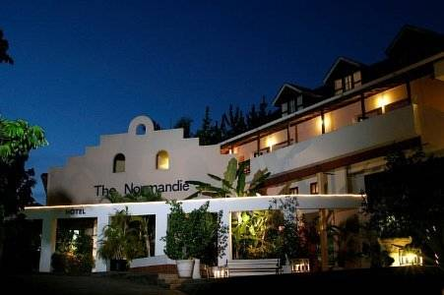

# GENERAL CONDITIONS

## Rules and Regulations

The Trinidad and Tobago International Masters and Open (TTIMO) Chess Tournaments 2016 will be held according to the FIDE Rules of Chess and the following General Conditions within this invitation.

## Categories

There will be two categories: **Masters and Open**.

Participation in the Master Class will be reserved for: (i) titled players with personal invitation from the Organising Committee, (ii) Fide rating greater than 2200 and

(iii) The organisers will ensure that the average rating of players in this section is greater than 2200.

The **Open** Class is open for all players from FIDE member federations. (ELO-Under 2100). There will be 5 sub-categories which will include: Female, Senior (50+), Under 20, Under 16 and Under 12.

## System of Play

* The Games for the Masters and the Open will be a Swiss System of **nine (9) rounds** or Round Robin depending on the number of players and at the discretion of the Chief Arbiter.
* The rhythm of play will be **ninety (90) minutes** for all the moves plus an increment of **thirty (30) seconds** per move from the initial move. The tournaments will be Fide-Rated, once the conditions for rating are met.

## Tie-Breaks

The final placings will be decided by the points obtained by each player. The player who obtains the most points will be declared the Champion. In the case of ties, the winners will be decided by the implementation of the following tie-break systems in the order mentioned:

1. Direct Encounter – Once the players have all played each other
2. Bulcholz
3. Sonnenberger
4. Most wins
5. Games with Black

In the event of a round-robin tournament, the following tie break system will be applied:

1. Direct Encounter
2. Sonnenberger
3. Koya System
4. Most Wins
5. Games with black

## Pairings & Results

Before the beginning of the First Round of the Masters and Open Tournaments, a list with all the names of participants will be published at the playing hall. The Pairings will be published at least **one hour** after the last game of each round, at the tournament’s Official webpage or Chess-results.com and at the venue's hall.

All winners are required to input their games on the computers provided. For drawn games, the player with white is required to enter his/her game.

## Discipline

a. The Tournament Organisers expect the highest standards of behaviour and fair play by the participants.

b. Default Time: **Thirty (30)** minutes.

## Prizes

**MASTERS**

**All prizes are in US$**

1st $2000

2nd $1500

3rd $1000

4th $800

5th $600

**Best player rated 2200 or under**

1st $400; 2nd $ 250; 3rd $ 150

**OPEN**

**All prizes are in US$.**

|  |  |  |  |  |  |  |
| --- | --- | --- | --- | --- | --- | --- |
| **Rank** | **Absolute** | **Female** | **50+** | **Under 20** | **Under 16** | **Under 12** |
| **1** | $800 | $500 | $300 | $200 | $150 | $100 |
| **2** | $600 | $300 | $200 | $100 | $100 | $50 |
| **3** | $400 | $200 | $100 | $75 | $50 | $25 |

The organisers reserve the right to award any additional special prizes.

## Titles and Norms

Titles and Norms shall be awarded as per Fide Title Regulations.

**BLITZ Tournament-OPEN**

There will be a 9-round (5 minutes) Open Blitz tournament after the end of the last round of the Masters and Open tournaments.

**Registration:** US$10.00/TT$ 65.00 per person

# THE EVENT TIME TABLE

| Date | Time | Activity |
| --- | --- | --- |
| Thursday 28th July, 2016 | 12.00 p.m. – 8.00 p.m. | Arrival & Registration |
| Friday 29th July, 2016 | 10.00 a.m. | Technical Meeting |
| Friday 29th July, 2016 | 4.00 p.m. | Opening Ceremony |
| Friday 29th July, 2016 | 6.00 p.m. | Round 1 |
| Saturday 30th July, 2016 | 10.00 a.m. | Round 2 |
| Saturday 30th July, 2016 | 5.00 p.m. | Round 3 |
| Sunday 31st July, 2016 | 10.00 a.m. | Round 4 |
| Monday 1st August, 2016 | 10.00 a.m. | Round 5 |
| Monday 1st August, 2016 | 5.00 p.m. | Round 6 |
| Tuesday 2nd August, 2016 | 5.00 p.m. | Round 7 |
| Wednesday 3rd August, 2016 | 5.00 p.m. | Round 8 |
| Thursday 4th August, 2016 | 10.00 a.m. | Round 9 |
| Thursday 4th August, 2016 | 3.00 p.m. | Blitz-OPEN |
| Thursday 4th August, 2016 | 7.00 p.m. | Closing Ceremony |
| Friday 5th August, 2016 | 12.00 p.m. | Check-Out/Departure |

# PARTICIPANTS’ COSTS

## 1. Covered costs

1. For players who hold the titles of GM/WGM/IM/WIM with an ELO rating>2200 and have been extended a personal invitation, the Organizing Committee will cover the cost of accommodation (double occupancy) and meals.
2. For the invited GMs/WGMs/IMs/WIMs, meals will be covered from dinner on **28th July** to breakfast on **5th August, 2016**.

3) Those persons who wish to upgrade to single occupancy shall pay the additional cost as per schedule under ‘Accommodation’.

4) Any exceptions to these conditions will be at the discretion of the organisers.

## Registration

a. Pre-Registration of the participants must be made with the details of each participant. The Participant information must include: Name, FIDE Title, FIDE ID, FIDE ELO, Date of birth, e-mail address and Federation name, on or before **July 15th 2016** to [**ttimochess@gmail.com**](mailto:ttimochess@gmail.com)**.**

b. **Masters:** Registration fee: (Non-resident) US$100.00; (Local players) US$50.00

**Open:** Registration Fee (Non-Resident): US$75.00; US$40 (Under 20);

Registration Fee **(**Local players): US$30.00/TT$200.00;

US$20.00/TT$130 (Under 20)

1. Transportation will be provided for non-resident persons to and from the airport. This is included in the registration fee.

Organisers reserve the right to make changes to these arrangements on a case by case basis.

Players who have not paid the registration fee by the beginning of the tournament will not be paired.

Participants who pre-register after **July 15nd, 2016** will be penalized by paying an additional **US$50.00** which represents the late registration fee. The rationale being that the organisers need sufficient lead time to confirm the hotel reservations for the participants and accompanying persons. The deadline for late pre-registration is **July 22nd, 2016**.

c. On the day of registration the original passport or ID must be provided for each player.

d. The onsite registrations will close on **28th July 2016, at 8:00 p.m.**

## Payment

Payment of registration fees and accommodation must be made by **Bank Wire Transfer** by **July 15th, 2016** or as otherwise authorized by the Organisers.

Funds to be sent to:

**Wells Fargo Bank N.A.**

**Philadelphia, Pennsylvania**

**Swift code: PNBPUS3NNYC or ABA 026005092**

**For Credit to: Swift Code FCTTTTPS**

**First Citizens Bank Ltd.**

**One Woodbrook Place**

**Woodbrook**

**Trinidad & Tobago**

**Beneficiary: TTCA**

**Beneficiary Account No.:2016303**

Upon completion of wire transfer, a scanned copy of the transfer receipt should be emailed to TTCA’s Secretary and Treasurer at:

**President:** Sonja Johnson; e-mail:**sonjagia.johnson@gmail.com**

**Secretary**: Sandy Razark; e-mail: **srazark@yahoo.com**

**Treasurer**: Debra Walcott; email: **debra.charleswalcott@gmail.com**

Once the payment transfer is confirmed, the organising committee will confirm the hotel reservation.

## Cancellations after payments made

These will be treated on a case by case basis.

# ACCOMMODATION*

The following accommodation arrangements shall be made available to players and other guests.

|  |  |  |  |
| --- | --- | --- | --- |
| **Hotel** | **Single**  **US$** | **Double**  **US$** | **Triple**  **US$** |
| **Normandie Hotel** | 70.00 | 50.00 | 45.00 |

Prices are **per person/per night** and are in **US$.**

**Meals**

Breakfast $ 8.00; Lunch $ 15.00; Dinner $15.00

**\* Important**: The Organisers are not responsible for any Participants (chess players, accompanying persons) who choose to stay outside the official hotel of the Organisation.

Any arrangements other that what is displayed above will be determined on a case by case basis by the tournament organisers.

**The organisers have negotiated with the hotel to maintain the same level of pricing for accommodation and meals pre- and post-tournament dates for the participants in the International tournaments.**

# TRANSPORTATION

Transportation expenses of persons from their place of origin to Trinidad (and vice versa), are the responsibility of each player/federation.

Transfers from the airport-hotel and hotel-airport (round trip) will be provided and are included in the registration costs. Players must inform the organisers about their flight schedules **at least 2 weeks** in advance of arrival.

# OTHER INFORMATION

## Media

All journalists are welcome and those who wish to participate in the event may contact the Organisers for accreditation.

## Organising Committee

The Core Organising Committee comprise:

* Sonja Johnson, Organising Committee Chairperson, 1st Vice President-TTCA
* Sandy Razark, Secretary- TTCA
* Roderick Noel-VP of Southern Chess Club

***Sub-Committee***

* Bhisham Soondarsingh, VP TTCA
* Elyse Harlow, PRO TTCA

## Arbiters

**Chief Arbiter**: IA Rohan Waithe, Barbados

The Deputy Arbiter and assistant arbiters would be selected at the discretion of the TTCA and in accordance with Fide Regulations.

## Appeals Committee

At the Technical Meeting, the appeals committee will be constituted by five (5) representatives of the Federations: three (3) principal representatives and two (2) substitutes. No member of the appeals committee shall adjudicate on matters involving his/her federation.

## Communication

Telephone: 868 681 1151/ 683-4439

Email English/Spanish: ttimochess@gmail.com

Website: [www.chesstt.org](http://www.chesstt.org)

**The Trinidad and Tobago Chess Association (TTCA) is excited for you to be part of this historic event as we celebrate 80 years. We are confident that this will be a tournament for all to remember!**