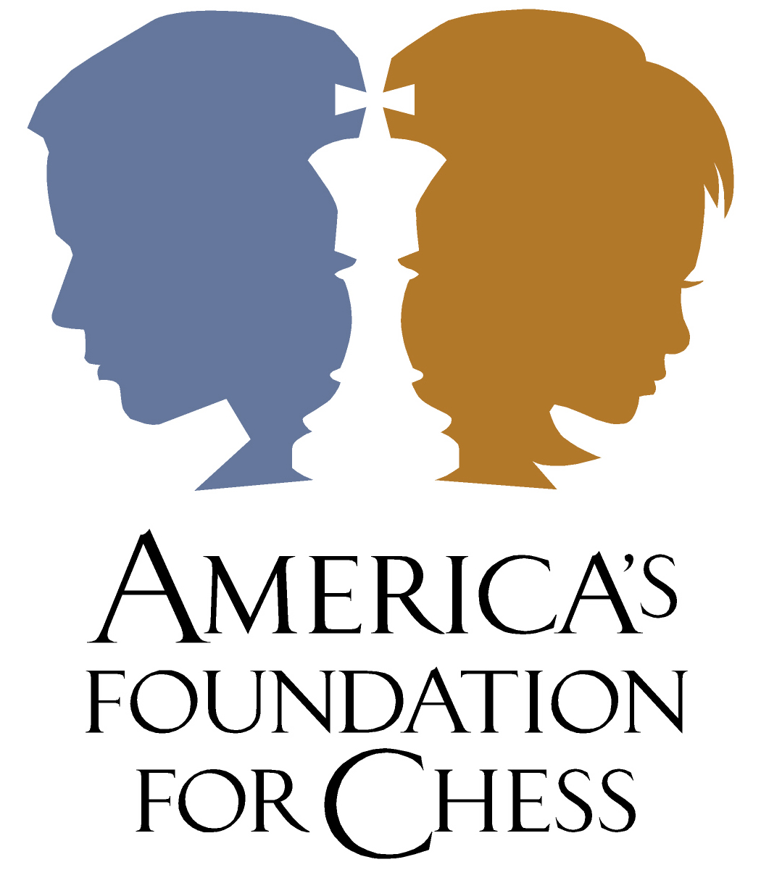

News Release

Date: January 25, 2006 | Contact: John Henderson, 206.229.9233  Media Relations and Special Projects

THE SHAUN ALEXANDER FOUNDATION SPRINTBLITZ CHESS CELEBRATION AT MADRONA SCHOOL

SEATTLE – Jan.25, 2006 - The awards are coming thick and fast for Shaun Alexander, Seattle Seahawk’s MVP running back, that he’s starting to lose track of them.

A day after scoring two touchdowns to lead the Hawks (who beat the Carolina Panthers 34-14) to a first Super Bowl appearance in their 30-year history, Alexander returned to Madrona Elementary School in Seattle to hand out the prizes at a special chess tournament organized by America’s Foundation for Chess.

Just before Christmas, Alexander, who is a keen chess player, announced his support for the AF4C’s First Move™ Program at Madrona with a generous $7,500 grant from The Shaun Alexander Foundation (www.shaunalexander.org) as part of the star running back’s key initiatives to inspire kids to stay in school, strive for educational excellence and plan their futures.

In conjunction with Shaun’s commercial sponsor, Sprint Nextel, a “Pawn Game” chess tournament was organized for 150 second, third and fourth grade students participating in the First Move™ chess program at Madrona, with the winner receiving an all-expenses-paid trip for two to Hawaii, donated by Sprint, to see Shaun play in the 2006 Pro Bowl on Feb. 12.

After three hours of intense and spirited play, 8-year-old Gerume Malaku proved to be the worthy winner of the chess tournament after beating 9-year-old Roger Howard 3-2 in the final. Gerume also got to play Shaun Alexander at chess. Surrounded by a media pack and all his fellow students, Gerume unfortunately proved no match for the quick footed Alexander, who checkmated his young opponent!

For added excitement, Shaun Alexander was also on hand to draw out a lucky winner of all the kids who played in the tournament to receive an additional all-expenses-paid trip for two to Hawaii, which went to 8-year-old Urael Tedros. Both Gerume and Urael (and their families!) will now go to Hawaii to watch Shaun Alexander play in his third Pro Bowl – and all because they are part of AF4C’s First Move™ program!

"This gift from Sprint will result in a once-in-a-lifetime experience for a student whose family would not normally have the means to take this trip," said Shaun Alexander. "Moreover, it will reward a young person who has decided that education is his number one priority. When companies like Sprint commit to helping us make a difference for the young people in our community, we create a stronger and more effective winning team."

"Shaun is a true role model for so many children ... not just in Seattle, but across the country," said Kirk Dawson, Sprint's consumer area vice president for the Northwest. "It is an honor for Sprint to work with him to support the mission of his foundation. We believe his commitment to the young men and women he mentors will result in much brighter futures for them and a stronger community for those around them."

It’s been nothing short of a stellar season for Alexander The Great. After winning league MVP honors, he was named the NFL's Offensive Player of the Year by The Associated Press. The star running back rushed for a league-best 1,880 yards and scored an NFL-record 28 touchdowns, earning 34 of the 50 votes from the panel of sportswriters and broadcasters who vote on the AP's postseason awards.
# # #
About The Shaun Alexander Foundation
The Shaun Alexander Foundation is a non-profit organization whose mission is to empower young men through education, athletics, character programs, and leadership training; inspiring them to reach their full potential as the mentors and role models for the next generation. For more information, visit www.shaunalexander.org.

About America’s Foundation for Chess
Founded on the hope of making chess a subject taught in every school in the United States, AF4C, a nonprofit organization, is committed to making chess a larger part of America's cultural fabric — accessible in schools and in popular culture. AF4C hopes to elevate the profile of chess in America so that it will soon become a regular part of every child's classroom experience. For more information, visit www.af4c.org.

About Sprint Nextel
Sprint Nextel offers a comprehensive range of wireless and wireline communications services to consumer, business and government customers. Sprint Nextel is widely recognized for developing, engineering and deploying innovative technologies, including two robust wireless networks offering industry leading mobile data services; instant national and international walkie-talkie capabilities; and an award-winning and global Tier 1 Internet backbone. For more information, visit www.sprint.com.

