The Marshall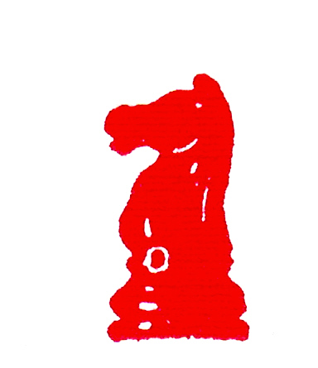 Chess Club
Presents

Chess Cheating Town Meeting

When: Monday, December 4th, 8:00-11:00 P.M.

Where: Marshall Chess Club, 23 West 10th Street, New York City
(212) 477-3716 www.marshallchessclub.org

Why:
With two much-discussed instances of alleged cheating during this year’s World Open, followed by the sensational accusations surrounding the recent World Championship match in Kalmykia, the potential for computer-assisted cheating has emerged as a major challenge facing the chess community.

Come and hear a freewheeling discussion among a panel of chess authorities and professional and amateur competitors, covering a variety of possible measures to combat cheating. The session will showcase expert views on a broad range of issues – legal, logistical, technological, and economic – that arise in connection with proposed anti-cheating measures.

Confirmed panelists:

Bill Goichberg, USCF President; and America’s dominant chess tournament organizer.
Grandmaster Alex Stripunsky, 2005 US Chess Championship runner-up
Dr. Danny Kopec, Brooklyn College computer professor, chess & computer author, Int’l Master
Nelson Farber, practicing attorney and active chess player
Steve Immitt, USCF's "Tournament Director of the Year" for 2005
Jon Jacobs, active non-professional competitor, chess author, anti-cheating activist.

Refreshments will be served.
Members of the Marshall Chess Club and invited guests free; others $10.00

Marshall Chess Club
23 West 10th Street
New York, NY 10011
Phone 212-477-3716 Fax 212-995-9281
www.marshallchessclub.org

