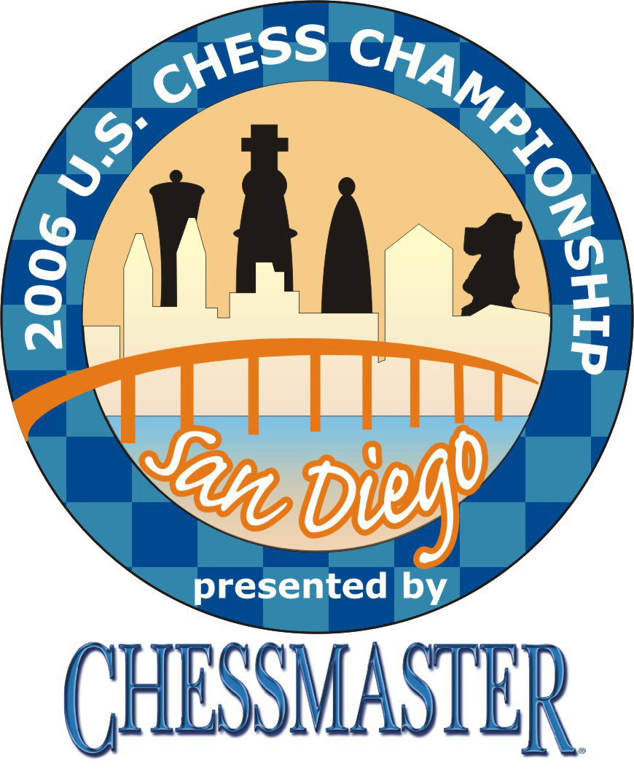


CALENDAR UPDATE
Please note new dates

U.S. Chess Championship Returns to San Diego
March 1- March 12, 2006

64 of the Nation’s Best Chess Players Compete for $250,000 in Cash Prizes

San Diego – October 23, 2005 - The U.S. Chess Championship returns to San Diego from March 1-March 12, 2006. The prestigious tournament will be held at its new permanent home at NTC Promenade. The Championship was brought to San Diego last year by America’s Foundation for Chess and the NTC Foundation and will be the first signature event to inaugurate The Corky McMillin Companies Event Center at NTC Promenade.

During the 9 rounds of high level match play, 17-year-old chess phenom Hikaru Nakamura will have an opportunity to defend the title he claimed last year in San Diego. Nakamura, a prodigy from White Plains, New York, became – at 16 - the youngest player to capture the U.S. Championship title since Bobby Fischer claimed it as a
14-year-old in 1957.

“Once again we are proud to be running the U.S. Chess Championship in conjunction with our partners in San Diego, and can only hope this championship lives up to the excitement of last year’s when Hikaru dramatically won the title,” said AF4C President Erik J. Anderson.

64 Chess Masters are planning their attack to out maneuver opponents in this prestigious event featuring exciting competition between the strongest players in the United States. Spectators will be able to meet the players and hear expert commentary during the matches. The 2006 tournament will highlight elite chess competition and also offer valuable educational activities sure to make chess more accessible to the public. Promoting chess as a learning tool that is fun, engaging and valuable is one of the main reasons AF4C and the NTC Foundation are collaborating to present this signature event.

2006 U.S. Chess Championship

Who: 64 of the Best Chess Players in the United States

What: 2006 U.S. Chess Championship Tournament

When: March 1- March 12, 2006

Where: NTC Promenade, San Diego, California

Prize money: Overall Champion $25,000
Women’s Champion $12,500

Cost: Free to the public

Time: All matches begin at 1 pm

In addition to the championship games, there will be other exciting events related to chess as part of Chess Fest 2006. For more information about the U.S. Chess Championships or the events surrounding the 2006 games, please visit www.uschesschampionship.com

America’s Foundation for Chess
Founded on the hope of making chess a subject taught in every school in the United States, AF4C, www.af4c.org a nonprofit organization, is committed to making chess a larger part of America's cultural fabric — accessible in schools and in popular culture. AF4C hopes to elevate the profile of chess in America so that it will soon become a regular part of every child's classroom experience.

About NTC Foundation
The NTC Foundation, a 501[c][3] nonprofit organization, is responsible for the renovation of the 26 historic buildings on 28 acres at the former San Diego Naval Training Center in Point Loma into a new arts, civic and cultural district called NTC Promenade. NTC Promenade will be the permanent home for the U.S. Chess Championship.

Contacts:
John Henderson, Chess Press Relations, 206-229-9233, jbthescots@yahoo.co.uk

