
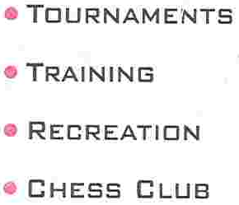



NCF
Vmobile ULTIMATE CHESS CHALLENGE


The Secretary, 6 Adeniyi Jakande Close, Off Adeniran Ogunsanya, S/Lere, LAGOS

August 8, 2005

Dear Chess Friends,

INVITATION TO PARTICIPATE IN THE FIRST V-MOBILE ULTIMATE CHESS CHALLENGE 2005

The Ultimate Chess Club and the Nigeria Chess Federation, invites all members of the FIDE Family to the First V-MOBILE Ultimate Chess Challenge to be held at the Union Bank Sports Club, #41, Bode Thomas Street, Surulere, Lagos Nigeria from September 12th – September 18th.

We take this opportunity to refer all intending participants to the attached General Regulations.

The Ultimate Chess Company looks forward to your contribution to a successful Tournament

Yours Sincerely,

ULTIMATE CHESS COMPANY
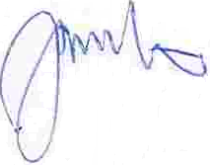

USEN JUMBO
Tournament Secretary

