MasterMinds Chess Club
CO-SPONSORED BY TEMPLE UNIVERSITY’S PASCEP PROGRAM INVITES YOU TO PLAY IN IT’S

CHESS TOURNAMENT

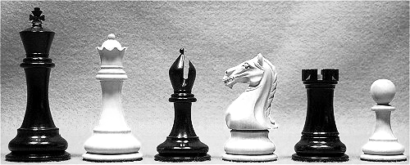
SATURDAY, DECEMBER 8TH, 2001
At
TEMPLE UNIVERSITY’S ANDERSON HALL ROOM 821 (8TH FLOOR)
12TH STREET BETWEEN NORRIS & BERKS STS.

5SS (Five Rounds), G/30. Entry Fee: $15
Rounds: 10:30-11:45-1-2:15-3:30. Registration ends at 10am
Prize fund $200.00 (Based on 50 entries)
1st Overall $50, Expert $25, Under 2000/$25, 1800/$25, 1400/$25, 1200/$25, Unrated/$25

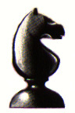 Also, free membership into the MasterMinds Chess Club for all prize-winners.

Note: Be sure to bring current USCF (United States Chess Federation) membership card with you or a recent Chess Life magazine with name and I.D. number displayed. Non-USCF members will have the opportunity to join during registration. USCF membership fee is $40.


Info: Contact Ernest Moore 215-235-1696 (ErnestEjay@aol.com),
Steve Slocum 215-455-6285 (Homeslice2U@msn.com),
or Elvin Wilson 267-496-0701 (Elvin_Wilson@msn.com)

