MasterMinds Chess Club
INVITES YOU TO EXPERIENCE ITS

INAUGURAL CHESS TOURNAMENT

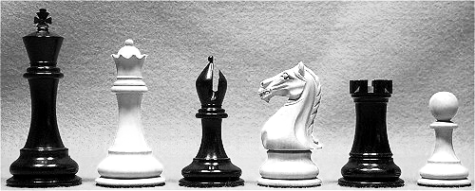
SATURDAY, AUGUST 4TH, 2001
At
TEMPLE UNIVERSITY’S ANDERSON HALL ROOM 821 (8TH FLOOR)
12TH STREET BETWEEN NORRIS & BERKS STS.

5SS (Five Rounds), G/30. Entry Fee: $15
Rounds: 10:30-11:45-1-2:15-3:30. Registration ends at 10am
Prize fund $200.00 (Based on 50 entries)
1st Overall $50, Expert $25, Under 2000/$25, 1800/$25, 1400/$25, 1200/$25, Unrated/$25

 Also, free membership into the MasterMinds Chess Club for all prize-winners.

Note: Be sure to bring current USCF (United States Chess Federation) membership card with you or a recent Chess Life magazine with name and I.D. number displayed. Non-USCF members will have the opportunity to join during registration. USCF membership fee is $40.


Info: Contact Ernest Moore 215-235-1696 or Elvin Wilson 215-858-7507 & Elvin_Wilson@msn.com

