PRESS RELEASE: 2002-10-29
Šahovska
Olimpiada
Bled, Slovenija
2002

BARBADOS & JAMAICA CLASH ENDS 2-2

The last time they met at a World Chess Olympiad was Thessaloniki 1988. The result then was 2-2 and 14 years on Barbados and Jamaica have still could not be separated.

The sides appeared evenly matched and this proved to be case with no one on either side able to make the breakthrough.

The first game to draw was on board 3 between FIDE Master Delisle Warner (2232) against Jomo Pitterson (2248) and this was quickly followed by Askari Elson (2138) on board 4 against veteran Bob Wheeler (2169).

With the bottom boards drawn, National Champion FIDE Master Ricardo Szmetan and FIDE Master Philip Corbin , anxious to avoid defeat, accepted the draw offers of FIDE Master Warren Elliott (2238) and Shane Matthews (2239) respectively.

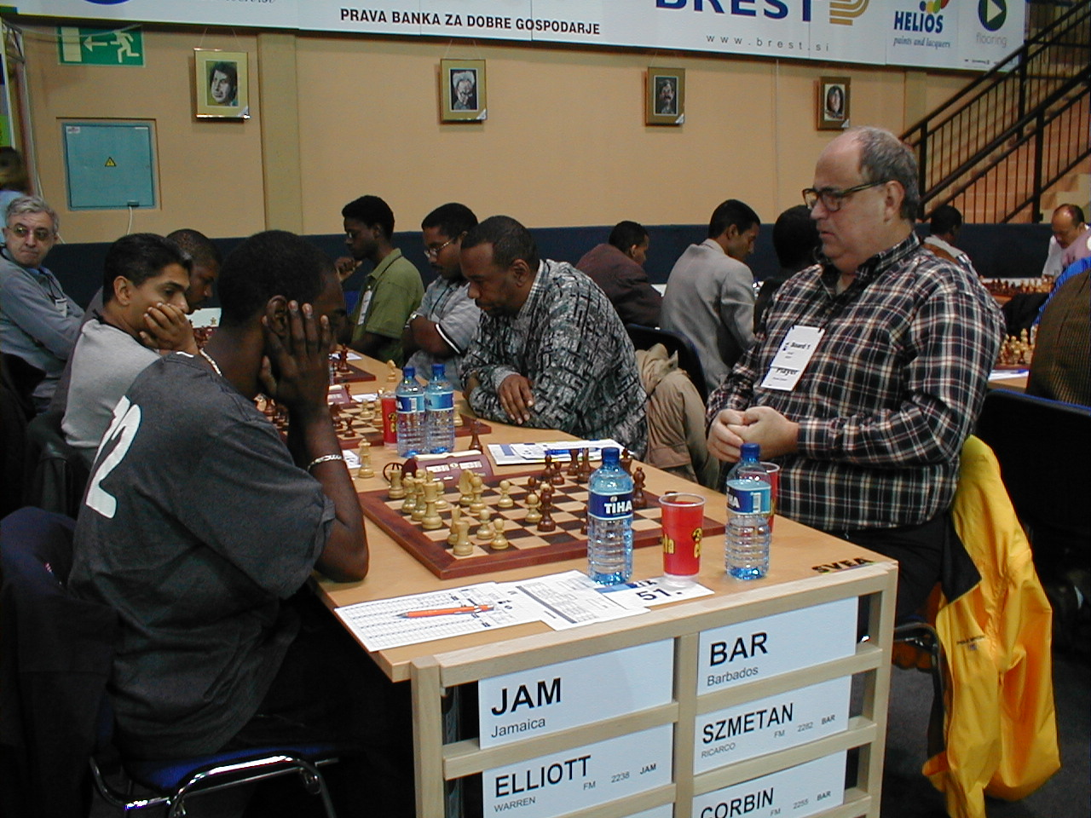

Barbados vs Jamaica in round 8.

Meanwhile the Bajan ladies miss a good opportunity to beat Lebanon after recovering from Rashida Corbin’s loss on board 2.

Rashaana Blenman who show good form convincingly won on board 3 to level the scores while top board Nathali Greenidge was a pawn up on board 1.

However, Greenidge miss a tactical shot and the Lebanese press on to victory.

Round 9 sees the Barbados paired against Turkey in the men and Brunei in the women. Both matches can be followed live on the internet at the BCF Web Site www.barbados.org/chess or the Olympiad Web site www.35chessolympiad.com.

