PRESS RELEASE: 2002-10-29
Šahovska
Olimpiada
Bled, Slovenija
2002

BARBADOS BACK IN WINNERS ROW

Barbados men bounced back to winner’s row in round 7 of the 35th World Chess Olympiad Currently being played in Bled Slovenia with a hard fought 2 ½ - 1 ½ win over Jersey.

Barbados begun badly with surprise loss by FIDE Master Delisle Warner (2232) on Board 2, before National Champion Ricardo Szmetan (2282) equalized on 1 with a convincing win over Anthony Fulton (2208).

Men’s coach Valerian Gaprindashvili decided to bring in fresh blood using top junior Askari Elson, sponsored by Illuminat, on board 3 and Kelvin Daniel on board 4. The move paid off with Daniel earning a draw while Elson battled to victory scoring the winning point for Barbados.

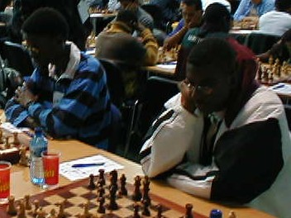

Bajans Askari Elso, left, and Kelvin Daniel, right, in match winning action

The women’s team also faired well in round 7 with a 1 ½ -1 ½ draw against Zimbabwe.

Top board Nathali Greenidge, sponsored by Mutual and its sports club, engaged in a tight tactical duel which ended with honours even. Nataional Women’s Champion Rashida Corbin and Rashaana Blenman also settled for draws. Both began well on boards 2 or 3 but were unable to turn their advantages into victories.

Russia widen the gap between itself and the rest of the competition by 2 ½ scoring a 3-1 victory over Poland. Playing for the Russia machine were Former World Champions Grandmasters Gary Kasparov (2838) and, Alexander Khalifman (2690), both of whom won their games, while Alexander Grischuk, (2702) and Alexander Morozevich (2707) both drew.

The question now facing everyone is not whether Russia win retain the men’s title but by how much.

Romania, Hungary, Bosnia & Herzegovina, Slovakia and Netherlands share second position on 19 points.

Top Caribbean team Cuba went under 3-1 to Israel, as did the Dominican Republic and Jamaica to Colombia and Paraguay respectively. Trinidad restored some pride to the Caribbean, with a 2 ½ - 1 ½ victory over Palestine.

Aruba destroyed US Virgins 4-0, Netherlands Antilles drew 2-2 with Hong Kong.

In the Women’s Section leader Georgia maintained their overall lead following a draw with Russia, though Defending Champions China narrowed the gap to a mare ½ point with a 3-0 crush over France. Russia and USA share 3rd place a further point behind.

Cuba remain the Caribbean’s top women’s team following a commanding 2 ½ - ½ win over Slovenia C. Dominican Republic and Puerto Rico both won against Japan and Lebon respectively, while Jamaica crashed to a 3-0 defeat at the hands of Malaysia.

Round 8 sees the Bajan men being pitted against Jamaica and the women take on Lebanon. Both matches can be followed live on the internet at the BCF Web Site www.barbados.org/chess or the Olympiad Web site www.35chessolympiad.com.

