PRESS RELEASE: 2002-10-29
Šahovska
Olimpiada
Bled, Slovenija
2002

JAMAICA DAY

Jamaica day! Well that was how it must felt for the Jamaican men’s and women’s teams as they white washed Hong Kong 4-0 and New Zealand 3-0 on day 6 of the 35th World Chess Olympiad Currently being played in Bled Slovenia.

Winning for the Jamaican men were FIDE Master Warren Elliot against (2238) against Edwin Borigas, Shane Matthews (2239) against SM Chau, Jomo Petterson against Mark Kiernan (2103) and Bob Wheeler against ST Fung.

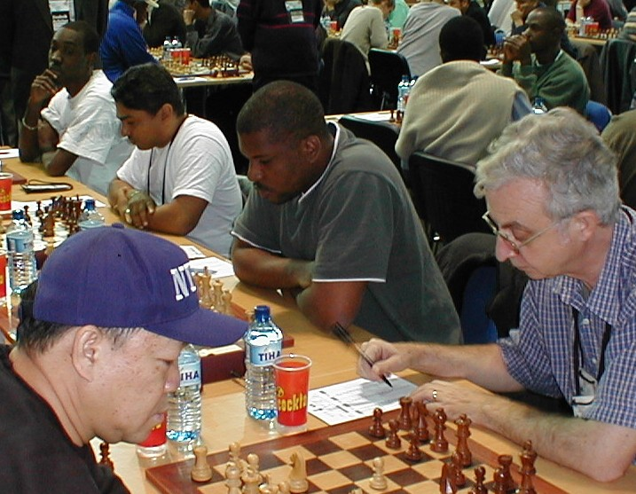

(r-l) Bob Wheeler, Jomo Pitterson, Shane Matthews and Warren Elliot in action for Jamaica

Spearheading the Jamaican women over New Zealand was Maria Palmer on board 1 against Vivian Smith, Deborah Ricards on 2 against Edith Otene and Hui Zuhi on 3 against Evgenia Charmova.

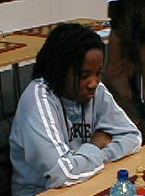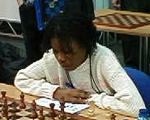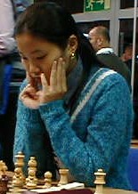

Maria Plamer, Deborah Richards and Hui Zui of Jamaica pictures of concentration

Round 6 however was a miserable day for Barbados, characterized by missed opportunities where neither the men’s or women’s team could muster more than a ½ point each against the players from the Physically Challenged Association and Costa Rica respectively.

Trouble for the Bajan men started when Kevin Greenidge (2055), sponsored by Central Bank, tactically outplayed Markku Pukkila (2150) in the opening only to catch cold feet in a completely won position and snatch defeat from the jaws of victory.

FIDE Master Philip Corbin (2255), sponsored by Light & Power, fared no better on board 2 against FIDE Master Miljenko Medic (2308). Playing a line he specially prepared with team coach Grandmaster Valerian Gaprindashvili of Georgia, Corbin mixing up his preparation, played an inferior move at the critical position and allowed Medic to seized the moment and grind out an easy win.

National Champion FIDE Master Ricardo Szmetan (2282) was out foxed by International Master Andrei Obodchuk (2423). Szmetan had difficulty in responding accurately to Obodchuk’s opening, losing first one then a second pawn. Obodchuck tighten his grip and press home to an easy win.

Fortunately for Barbados, FIDE Master Delisle Warner (2232) managed to stave off a white wash when he held on to a 64 move draw from Evgeny Vodyasov (2227).

In the Women, Costa Rica counted their lucky starts as Rashaana Blenman, sponsored by Neil & Massey, blundered horribly, a piece up, to lose to Eva Gonzales.

Natahlai Greenidge, sponsored by the Mutual and its sports club, continued her good form drawing with Sofia Lowsky, while Rashida Corbin, like her namesake on the men’s team, sadly took a leaf out of his book to misplay the opening line prepared with women’s team coach FIDE Master Richard Pert of England, and allow her opponent, Carla Da Bosco, an easy victory.

Top board action saw defending men’s champion Russia putting some distance between themselves and nearest rivals Poland and Romania.

The Russian’s went into overdrive scoring a big 3 ½ - ½ win against Bosnia & Herzegovina, this with their two most effective players, Garry Kasparov and Alexander Khalifman taking a rest. They now have 18 ½ points a clear 1 ½ points ahead of the rest.

Grandmasters Alexander Grischuk (2702), Alexander Morozevich (2707) and Peter Svidler (2690) sliced through the Bosnian top order like a hot knife through butter, and International Master Faruk Bistric (2520) prevented a complete rout by holding Grandmaster Sergei Rublevsky (2664) to a draw.

Armenia, obviously tired after the previous round match against the Russia, could not contain Romania who press for 2 ½ - 1 ½ win. Poland took a hard fought 3-1 win over Switzerland, with legend Viktor Korchnoi losing his first game of the Olympiad.

Romania and Poland move to 17 points, half a point ahead of Armenia, Czech Republic and Belarus on 16½ points.

Cuba had another good round, taking out Argentina 2 ½ - 1 ½ to move to 16th place with 15 ½ points. The Dominican Republic and Aruba scored big with 3 ½ - ½ victories against South Africa and Palestine, while the Netherlands Antilles and the British Virgin Islands drew 2-2 with Bermuda and Macau. Trinidad & Tobago crashed to a 3 ½ - ½ loss against none other than Iraq.

The dream run by the US women’s team came to a dramatic end toady when Russia brought them back to earth with a 2 ½ - ½ beating.

The US demise opened the door for Georgia who brushed aside the Dutch women 3-0. Georgia, with 12 points, hold a slim ½ point lead over 2nd place USA on 11 ½. The Czech Republic, Russia and the Netherlands share a 3 way tied for 3rd position with 11 points.

India held the Caribbean’s top women’s team Cuba to a 1 ½ - 1 ½ draw, causing them to fall to 26th position on 9 points. The Dominican Republic lost to Brazil 2-1 and Puerto Rica scarped up a ½ point to lose to Luxemborg 2 ½ - ½.

The Olympiad reached the halfway mark tomorrow with round 7 which will see Barbados paired against Jersey in the men and Zimbabwe in the womend. Both matches can be followed live on the internet at the BCF Web Site www.barbados.org/chess or the Olympiad Web site www.35chessolympiad.com.

