PRESS RELEASE: 2002-10-29
Šahovska
Olimpiada
Bled, Slovenija
2002

USA UPSET CHAMPIONS CHINA

Defending Women’s Champions China ran aground when they suffered a rear self-inflicted 2-1 defeat against the USA on day 5 of the 35th World Chess Olympiad in Bled, Slovenia.

The Chinese women appeared to be on course for a comfortable 3-0 win when the American’s board 3 Elena Donaldson (2375) lost to Zhao Xue (2367) and Irina Krush and Jennifer Shahade were just hanging on against Xu Yuhua and Wang Pin. But perseverance and luck rewarded the Americans as these two inferior positions became wins.

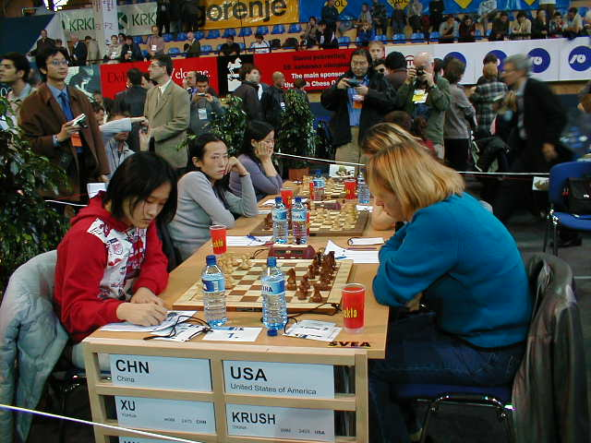

China’s Board 1 Zhao Xue could not save her team from the 2-1 upset by the US Women

The question buzzing around in the press room after the match was, with China and Georgia behind them, is the US finally on the road to performing the impossible? Responding to the press, US Team Captain Ilya Gurevich stated that "It´s still a long way and we have to play a lot of strong teams, and one of them is Russia!”.

Former Women’s Champion Georgia seized the opportunity presented by the Chinese demise to retake the tournament lead with a 3-0 drubbing of India. They now lead the Women’s Standing on 12 points, USA are 2nd with 11 ½ and the Czech Republic, Russia and the Netherlands tied with 11 points.

Day 5 for the Caribbean Women’s Teams was not bad with 3 of the 5 teams competing posting wins.

Cuba moved up the standings to 26th position with a much needed 2 ½ - ½ win against Finland. Winning for the Cuban Women were Women’s International Master Sulennis Pina Vega (2316) and Zika Frometa (2248). Women’s Grandmaster Maritza Arribas Robain (2348) drew with Finish Women’s International Master Nina Koskela (2271).

Barbados despite a win on board 1 by Nathali Greenidge (2019), who is sponsored by the Mutual and its sports club, were victims to the Dominican Republic’s losing 2-1. Sadly, Rashaana Blenman, sponsored by Neil & Massey, and reserve Margaret Prince just had a bad round blundering early in the opening to concede easy wins to Keyla Jose Polanco and Ariella Adames (1943).

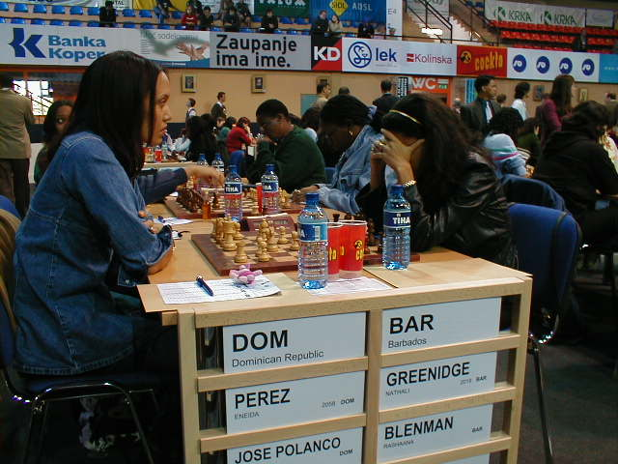

Nathali Greenidge, sponsored by The Mutual and its sports club, deep in concentration against Eneida Perez Lucke of the Dominican Republic

Jamaica scored their 1st team victory of the competition with a 2-1 win over Yemen. Winning for the Jamaicans were their top two boards Deborah Richards and Hui Zhu, while Vanessa Thomas drew on board 3 against Othman Nadmiha.

In Men’s action the Russia machine was stopped dead in its tracks by Armenia who held them to a 2-2 draw and Bosnia & Herzegovina toppled Poland 3-1 to take the tournament lead with 15 ½ points.

The Armenians neutralized Russia’s two top performers Grandmasters Gary Kasparov (2838) and Alexander Khailfman (2690) with draws on boards 1 and 3. Taking the precious half points for the Armenians was Grandmasters Vladmir Akopian (2689) and Karen Asrian (2597).

Grandmaster Alenander Morozevich (2707) won for the Russians against International Master Gabriel Sargissian (2568), while Grandmaster Alexander Grischuk (2702) dropped his first game of the Olympiad for losing to Grandmaster Smbat Lputian (2627).

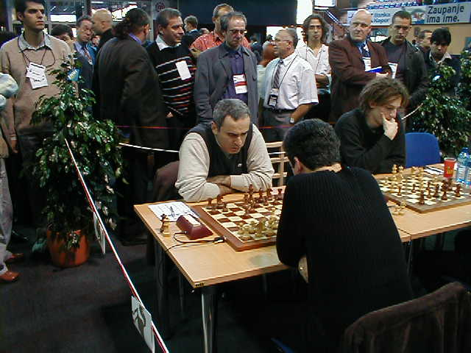

Garry Kasparov and Alexander Grischuk of Russia

In other top board results Romania move into 4th position behind Russia and Armenia with a 3-1 win over France. Ukraine, with World Champion Ruslan Ponomariov (2743), and the Czech Republic drew 2-2 to drop to a 6 way tie for 5th with Poland, England, who finial decide to join the party with a big 4-0 victory over Chile, Hungary who defeated Moldova 2 ½ - 1 ½ and Switzerland, with legend Viktor Korchnoi, who trashed Kazakhstan 3 ½ - ½ .

Cuba, as happens time and again in world sport, continued to represent the Caribbean with a tough fought 2-2 no result draw against The Netherlands. The Cuban all Grandmaster line up included Lazaro Bruzon (2613), Lenier Dominguez (2608), Reynaldo Vera (2544) and Walter Arenciba (2521) who all drew against the Dutch Grandmasters of Loek Van Wely (2681), Ivan Sokolov (2684), Sergei Tiviakov (2631) and Friso Nijboer (2556). The Cubans now have 13 points and are in 19th position.

Barbados, Jamaica and the Netherland Antilles had horrid 5th round games losing 4-0 to Scotland, Peru and Surinam respectively. Trinidad and the US Virgin Island fared a little better, but only just, going under to Lebanon and Rwanda 2 ½ - 1 ½. The British Virgin Island drew 2-2 with Somalia and Aruba won 2 ½ - 1 ½ against Bermuda.

In a match no one will want to remember, the Bajan men had a terrible day letting the Scottish team get way “scotch free”. Playing for Barbados was National Champion Ricardo Szmetan (2282) who lost to Grandmaster Paul Motwani (2525), FIDE Master Philip Corbin, sponsored by Light & Power, who lost to International Master John Shaw (2484), FIDE Master Delisle Warner (2232) who went under to Grandmaster Colin McNab and Askari Elson (2138), sponsored by Illuminat, losing to International Master Stephen Mannion (2367)

Day 6 of the Olympiad will be unique for the Bajan men as they are paired with the team from the International Association for the Physically Challenged. The Women take on Costa Rica. Both matches can be followed live on the internet at the BCF Web Site www.barbados.org/chess or the Olympiad Web site www.35chessolympiad.com.

