PRESS RELEASE: 2002-10-27
Šahovska
Olimpiada
Bled, Slovenija
2002

CUBA TOP THE BOARDS IN BLED

Day two of the 35th World Chess Olympiad, currently underway in Bled, Slovenia, saw a number of Caribbean nations register massive wins.

Pride of place goes to 18th seed Cuba who registered a 3 ½ - ½ crush against 50th seed Bangladesh to share the top spot with 32nd ranked Bulgaria on 7 ½ points.

Cubans Grandmasters Lazaro Bruzon, Reynaldo Vera and Walter Arencibia won on boards 1, 2 and 4 against Grandmaster Ziaur Rahman, International Master Bin-Sattar Reefat and International Master Enamul Hossain.

Bangladesh’s only respite came on board 3 where International Master Al-Rakib Abdulla drew with Grandmaster Neuris Delgado.

Barbados and Trinidad also registered 3 ½ - ½ blow outs against Papua New Guinea and Aruba respectively, while Jamaica smashed Guernsey 4-0.

The Jamaican damage to the Guernsey team was inflicted by FIDE Master Warren Elliot, Jomo Pitterson, Duane Rowe and Robert Wheeler.

Led by Former National Champion, FIDE Master Delisle Warner, the Bajans witnessed Warner dismember a hapless Alan Luga on board 3. This was quickly followed with wins by National Champion FIDE Master Ricardo Szmetan and Kevin Greenidge on boards 1 and 4 against Jeppers Alibis and Joselito Marcos respectively.

Papua New Guinea’s only resistance from came from Shaun Press who played well to contain FIDE Master Philip Corbin to a draw on board 2.
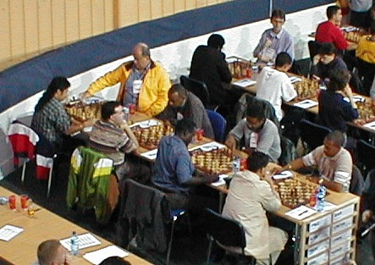

Papua New Guinea – Barbados Match: Szmetan, Corbin, Warner and Greenidge

Trinidad’s points were scored by their National Champion FIDE Master Ryan Harper on board 1, FIDE Master Mario Merritt on board 3 and a fortunate Ravishen Singh on board 4 against Octavio Croes, Jose Pesqueria and John da Silva respectively. Yogendranath Ramsingh drew with Willem Jacobiusse on board 2.

Number 1 seed Russia fielded Gary Kasparov to take out rivals Belarus 3 ½- 1/2. Winning for the Russians were Kasparov on board 1, Former World Champion Grandmaster Alexander Khalifman on board 3, and Peter Svidler on board 4. Grandmaster Alexander Grischuk drew with Alexi Fedorov on board 2.

Bulgaria defeated Albania 3 ½ - ½ and the USA struggled to a 2 ½ - 1 ½ win against the Philippines. France fared no better and were also bogged down by Scotland with a 2 ½ - 1 ½ win. Hungary, Poland, Romania, Georgia and Slovakia registered 3-1 victories against Vietnam, Italy, Portugal, Ireland, Peru and Iran respectively.

In Women’s action, Defending Women’s Champion China fell a half point behind archrivals Russia when the only managed a 2 ½ - ½ win against Belarus. Russia seized the tournament lead with a fine 3-0 shut out of Croatia.

Argentina, Philippines and Venezuela crashed to a 2 ½ - ½ drubbings against Romania, USA and Armenia respectively. Yugoslavia and Germany won 2-0 against Estonia and Australia

The Barbados Ladies Team had another difficult match losing 3-0 to Brazil. The Bajan line-up of Nathali Greenidge, National Champion Rashida Corbin and Rashaana Corbin went under to Suzana Chang, Women’s Inetrnationa Mastet Joara Chaves and Iara Santana.

Jamaica, the only other English Speaking Caribbean country with a Ladies Team at the Olympiad, afer slightly better with a 2 ½ - ½ defeat against Iceland. Putting the Jamaica’s Maria Palmer and Vanessa Thomas on ice were Lilja Gretarsdottir and Aldis Larusdottir. Deborah Richards drew against Harpa Ingolfsdottir.

Games and live video from the competition can be found at the Olympiad Web site http://www.35chessolympiad.com/.

