PRESS RELEASE: 2002-11-10
Šahovska
Olimpiada
Bled, Slovenija
2002

TO JAPAN WITH LOVE

By a mystical lake where one can dream of fairies and wraiths, the Barbados Women’s Team posted its largest win of the 35th World Chess Olympiad when they dismantled Japan 3-0.

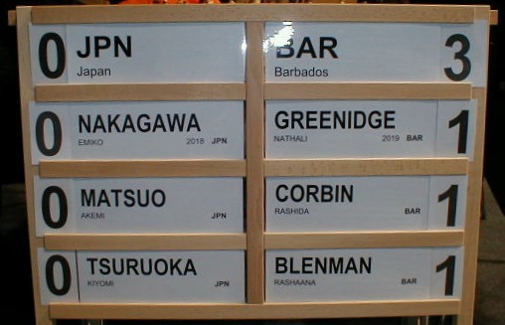

Team coach, International Master Richard Pert, was ecstatic as he witnessed his pre-match preparation come to fruition. In fact, so comprehensive was the Pert’s preparation that on one board the Japanese went from opening to mate and on another material loss without deviation from the preparation.

Winning for Barbados was Nathali Greenidge, National Women’s Champion Rashida Corbin and Rashaana Blenman, against Emiko Nakagawa (2018), Akemi Matsuo and Kiyomi Tsuroka.

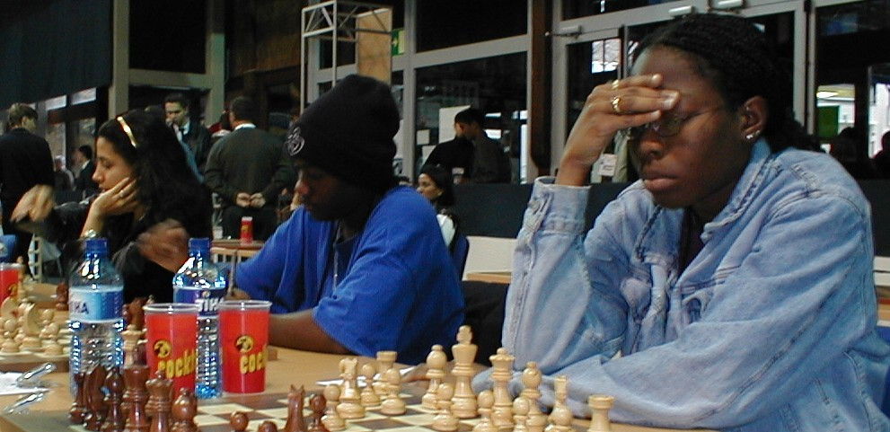

Rashaana Blenman, Rashida Corbin and Nathali Greenidge of Barbados (r-l)

In terms of individual board performances, Greenidge, who is sponsored by Mutual and its sports club, is one of the only two untitled players in the Board 1 top 20 standings. She is currently is 17th overall with a percentage score of 62.5%.

Blenman, sponsored by Neil & Massey, with a percentage score of 54.2% is in 40th position on the board 3 standings.

The Barbados Men’s team had another disappointing round losing 3-1 to Sri Lanka.

The Bajan’s only point came from top junior Askari Elson who is sponsored by Illuminat. Elson completed out played T.D.R Pieris on board 3, but his efforts were in vain as National Champion FIDE Master Ricardo Szmetan, FIDE Master Delisle Warner and Kevin Greenidge, sponsored by the Central Bank, all lost to Nirosh De Silva, Laxman Wijesurija and M.K.A Russell respectively.

Russia with 36 ½ points and Hungary with 34 ½ currently hold 1st and 2nd position in the men.

With one round to go, the Russians and Hungarian whipped off quick 2-2 draws against Israel and Armenia. It appears that Hungary now seem contented to cruise to the silver medal rather than take risks trying to catch the Russians.

Georgia on 3rd position with 33 points will have to be very careful in the last round as they will have China on 32 ½ points and Armenia on 32 breathing down their necks.

The top Caribbean side is Cuba who are currently 29th with 29 ½ points having beaten Finland 2 ½ - 1 ½.
Dominica Republic have 26 points, Jamaica 23 ½, Trinidad 22 ½ and Barbados and the British Virgin Islands 22.

The race for the Women’s title was blown completely open when Georgia fell to Bulgaria 2-1giving Defending Champions China who drew 1 ½ - 1 ½ with Ukraine the sole lead with 27 points.

Russia despite being held to a 1 ½ - 1 ½ draw by Vietnam are in 3rd position with the Georgians on 26 ½ points.

As with the men, Cuba are the top Caribbean women’s team in 31st position with 21 points. Barbados have 17 points, Dominican Republic and Puerto Rico 16, and Jamaica 15.

The final round of the Olympiad will see Barbados playing Brunei in the men and the Association for the Deaf in the Women. The fortunes of both Bajan teams can be followed live on the internet at the BCF Web Site www.barbados.org/chess or the Olympiad Web site www.35chessolympiad.com.

