PRESS RELEASE: 2002-10-29
Šahovska
Olimpiada
Bled, Slovenija
2002

BAJAN WOMEN BEAT YEMEN

The Barbados Women’s team, lead by Nathali Greenidge on board 1and Rashaana Blenman on 2, posted their second win of the 35th World Chess Olympiad when they beat Yemen 2-1.

Greenidge, sponsored by Mutual and its sports club, easily outplayed Buthaina Al-Qershi in the opening winning a rook at move 22. Al-Qershi resigned 3 moves later when she realized that she would lose her queen in a force combination.

Nasher Saed Merfat suffered a worst fate against Rashaana Blenman, when Belnman’s opening preparation earned her a free Knight at move 8. This was followed by a bishop 4 moves later and Mefat’s Queen at move 18. An unrelenting Blenman, who is sponsored by Neil & Massey, drove Merfat King first into the center of the board before backing her in to a mating position on the queenside.

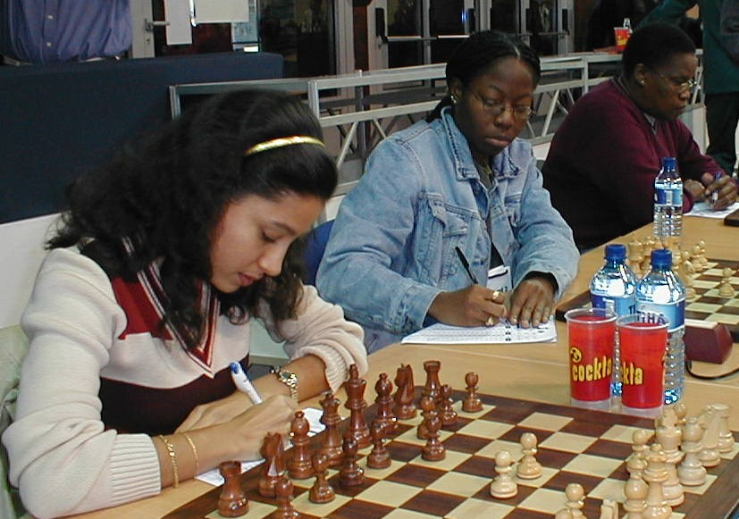

Barbados Women’s Team of Nathali Greenidge, Rashaana Blenman and Margaret Prince

Othman Nadmiha provided Yemen’s only point when Margaret Prince miscalculated an exchange of pieces which left her bishop down.

In Men’s action, Barbados drew 2-2 with Hong Kong, thanks to dashing wins by FIDE Master Philip Corbin and top junior Askari Elson on boards 1 and 2 respectively.

Corbin (2255), who is sponsored by Light & Power, steamed rolled Chor Yuen Chong (2156) in typical Corbin fashion while Elson (2138), sponsored by Illuminat, gave Edwin Borigas an object lesson on the exchange sacrifice.

The Bajan’s hopes of a big win were however thwarted when SM Chau got the better of Kevin Greenidge, who is sponsored by the Central Bank, in his pet opening the Dutch Defense and Kelvin Daniel (2033) found himself in unfamiliar ground in the Caro Kann against the experienced Mark Kierman (2103). Greenidge and Daniel both lost allowing Honk Kong to tie the match.
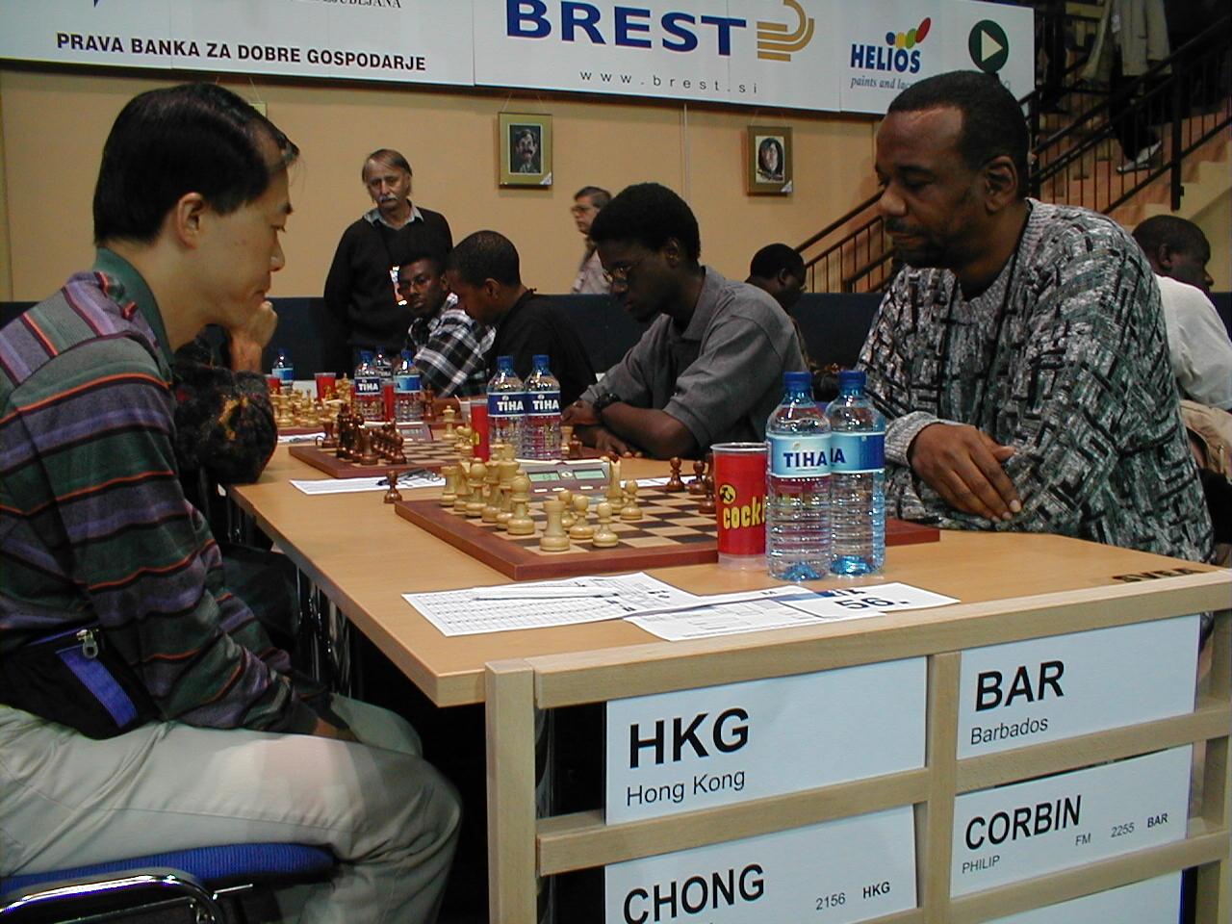

FIDE Master Philip Corbin, Askari Elson, Kevin Greenidge and Kelvin Daniel in action against Hong Kong.

For Jamaica, Trinidad and the Netherlands Antilles round 10 in men’s action was a disaster with each suffering 4-0 losses to Lebanon, Albania and the Dominican Republic respectively. Cuba were in fine form with a 3 ½ - ½ result against Belgium. For the Virgin Islands, USVI worked out a much needed 2 ½ - 1 ½ win over Papua New Guinea and the BVI lost 3-1 to Lybia.

Russia gained an additional ½ point lead in the standings when the moved to 28 ½ points after winning 3-1 against China. Hungary on 27 ½ stay within striking distance after a hard fought 2 ½ - 1 ½ win against Bosnia & Herzegovina.

England has at last moved into the top 3, sharing 3rd position with Germany on 26 points. England beat India, who are missing their super Grandmaster Former World Champion Anand, 3-1 while Germany score 3 ½ - ½ against the Czech Republic.

Georgia continues dominate the Women’s section with 24 points after a 2-1 win against Hungary.

Defending Champions China are second on 21 ½ and USA and Russia are tied for 3rd with 20 ½ points.

Losing to the Chinese, Americans and Russians in round 10 were Greece 2 ½ - ½ , India 2-1 and Slovakia 2-1.

Barbados goes into round 11 with a difficult to judge match against Lybia in the men. The women’s team will certainly have a hard task against Luxembourg as top board Nathai Greenidge is being rested to recover from the flu.

The fortunes of both teams can be followed live on the internet at the BCF Web Site www.barbados.org/chess or the Olympiad Web site www.35chessolympiad.com.

