PRESS RELEASE: 2002-10-26
Šahovska
Olimpiada
Bled, Slovenija
2002

RUSSIA FUMBLE OPENING GAME
AT CHESS OLYMPIAD

Defending champion Russia failed to join the list of 4-0 opening day winners in the 35th World Chess Olympiad in Bled, Slovenia, when a 14-year-old boy from Costa Rica drew with Super Grandmaster Alexander Morozevich.

The Russians decided to rest their top two players Grandmasters Garry Kasparov and Evgeny Bareev for what should have been an early day at the office, a tactic commonly employed by many top teams in the opening round.

Everything seemed to be going according to plan with Grandmasters Alexander Grischuk, Alexander Khalifman and Peter Svidler delivering the victories on boards 1, 2 and 4.

What was not anticipated was the resolve and mature play of the 14 years Costa Rican junior, International Master Alejandro Ramirez, on board 3. Ramirez with total disregard for whom he was playing forced the precious draw from Morozevich who was later seen explaining the situation to a disbelieving Kasparov.

Surprisingly Hungary and the USA were the only two top 10 teams not to drop any points when they delivered 4-0 drubbings to Venezuela and the team from the International Association for Physically Challenged Players.
For the English Speaking Caribbean, the opening round was not pleasant with Jamaica, Barbados, Trinidad & Tobago, and the US Virgin Island all going under 4-0 in the Men’s section to Croatia, Denmark, Moldova and Ecuador respectively.

Jamaica, who is the highest seeded English Speaking Caribbean country at 98, fell to Croatia, with FIDE Master Warren Elliot, Duane Rowe, Bob Wheeler and Mark Smith losing to an all Grandmaster line-up of Zdenko Kozul, Ognjen Cvitan, Robert Zelcic and Nenad Sulava.

Barbados, seeded 99, lost to 29th seed Denmark. FIDE Master and National Champion Dr. Ricardo Szmetan and Former Champion, FIDE Master Dr. Philip Corbin strayed from their opining preparation to lose to Danish Grandmasters Peter Nielsen and Lars Schandorff.

Fearing no better were Former Champion, FIDE Master Delisle Warner who lost to International Master Vesterbaek Pedersen and Kevin Greenidge who went under to FIDE Master Davor Palo.

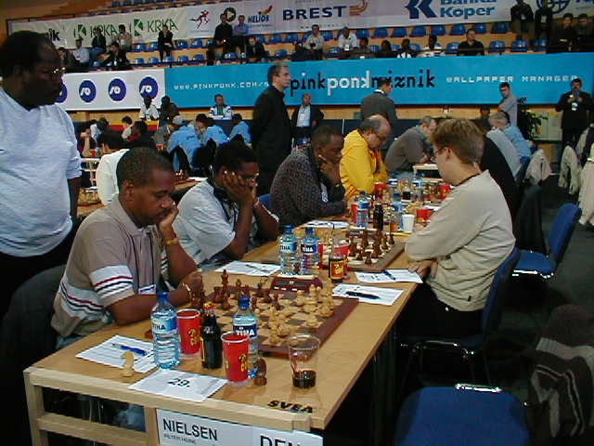

Barbados vs Demark: Kevin Greenidge (Board 4), FM Delisle Warner (Board 3), FM Philip Corbin (Board 2) and FM Ricardo Szmetan (Board 1)

Trinidad, seeded 104, also found the going tough against 34th seed Moldova. Losing for the Trini’s were their National Champion, FIDE Master Ryan Harper, stalwart Yogendranath Ramsingh, Former Champion Christo Cave and FIDE Master Mario Merritt.

In the Women’s section Defending Champions China firmly stuck their stake in the ground with a 3-0 win over Bosnia and Herzegovina.

Parading their lineup of reigning World Champion Zhu Chen, Wang Pin and Zhao Xue, the Chinese beat the Bosnians, led by Elena Titova-Boric, Diana Dengler and Aleksandra Dimovski.
Former champions and number 2 seed Georgia only managed a 2 ½ - ½ victory over Canada. Nana Ioseliani beat Nava Starr and Ketevan Arakhamia-Grant defeated Dinara Kharzieva. Untitled Dina Karganova prevented a Georgian rout by drawing Nino Khurtsidze.
Russia, the number 3 seed, matched the Chinese opening salvo by whipping Macedonia, 3-0. Scoring for the Russians were Ekaterina Kovalevskaya, Alexandra Kosetniuk and Tatiana Kosinsteva over Gabriela Koskoska, Vesna Sekulovska and Aleksandra Janevska.
Former National Ladies Champion Nathali Greenidge had an excellent opening match for Barbados almost defeating Women Grandmaster Mirijana Medic of Croatia. With this the Bajan Ladies suffered a 3-0 lost to the Cortians.

National Champion Rashida Corbin was defeated by Women International Master Vlasta Macek and Former Champion Margaret Prince went under to Mara Jelica.

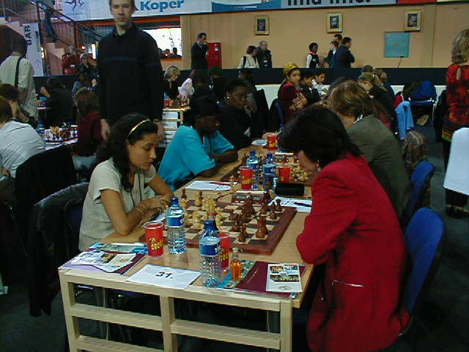

Barbados vs Croatia: Nathali Greenidge (Board 1), Rashida Corbin (Board 2) and Margaret Prince (Board 3)

The Jamaican women had what can be considered an excellent 1st round start when their Board 3 player Vanessa Thomas upset Women FIDE Master Ksenija Novak of the Slovenian B-Team. Sadly, the Jamaicans eventually conceded the match 2-1 when Deborah Richards and Hui Zhu lost to Women FIDE Master Vesna Rozic and Karmen Mar on Boards 1 & 2 respectively.

With over 140 countries participating, the Bled Olympiad has broken all records for a Chess Olympiad and based on the opening action is set to become one of the most keenly contested.

Games and live video from the competition can be found at the Olympiad Web site http://www.35chessolympiad.com/.

