TO: AFRICAN FIDE AFFILIATES

Dear Sir,

RE: LEWIS NCUBE: CANDIDATURE FOR AFRICAN CONTINENTAL PRESIDENCY

As you are aware, the global chess community will be gathering in the Slovenian city of Bled from November 1 to November 10, 2002 for the 73rd FIDE Congress. Elections for new FIDE office bearers will be conducted at the start of the General Assembly. Amongst the contested positions will be that of Continental President for Africa. I have been nominated by the Chess Federation of Zambia to contest this position and have duly accepted the challenge. The Government of the Republic of Zambia through the National Sports Council is in support of my candidature.

I believe that the sustainable development of chess in Africa can be achieved through the teamwork of the Continent’s administrators with inspirational leadership. In offering this leadership I commit myself to the ideals of sound and responsible management coupled with transparency and accountability.

I have detailed my abilities and achievements in the attached Curriculum Vitae and Profile. My electoral commitments are enunciated in the Vision statement.

The proposals detailed in my Vision statement are designed to EMPOWER African Federations and their players so that the implementation of FIDE and African Chess Union (ACU) development programmes are based on collective teamwork rather than particular individuals. This will ensure the sustainability of the resultant successes.

As I seek your support, I am available for any queries or clarification regarding my candidature.

Yours sincerely,

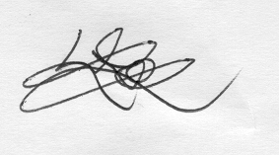
Lewis Ncube
President, Chess Federation of Zambia

